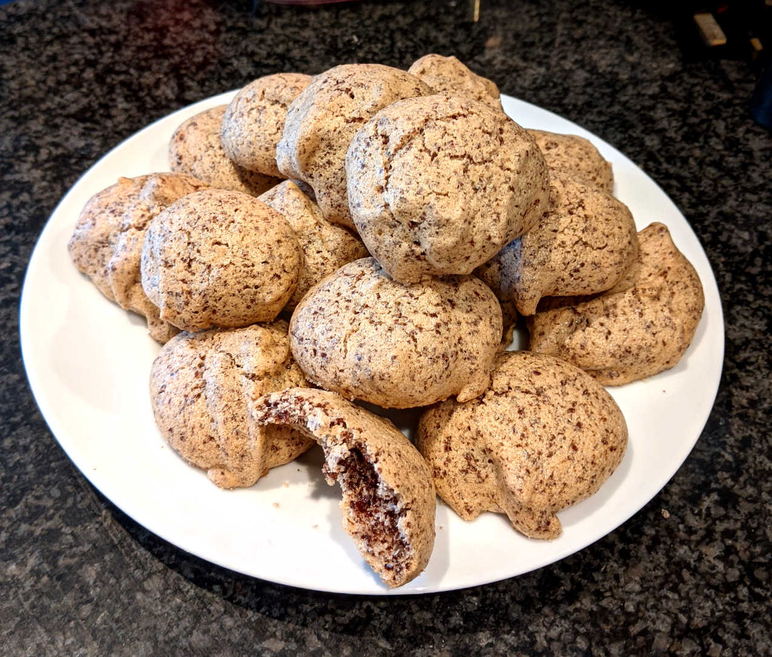

This recipe has been adapted to use modern ingredients and is taken from the item 'From Hand to Mouth: Cookery Recipes and Household Hints Supplied by Members of the Berkshire Federation of Women's Institutes.', 1944.

It is amongst the papers of the Castle family of Home Farm, Charlton which are held at the Berkshire Record Office; document reference D/EX2547/4/6/6.

[Click on this online catalogue link](http://ww2.berkshirenclosure.org.uk/CalmView/Record.aspx?src=CalmView.Catalog&id=DEX2547%2f4%2f6%2f6&pos=1) if you would like to find out more about the collection.

**Method**

Pre-heat the oven to a moderate 180o/160o fan/Gas Mark 4.

Prepare the ingredients as described in the ingredients list.

In a large bowl, gently mix all the ingredients together.

Butter and greaseproof paper a baking tray (use an extra tray if required).

Dust sugar over the greased tray.

Shape the mixture into little balls – about the diameter of a 10p coin.

Place the balls on the tray, allowing space between each ball to spread during baking.

Bake for 10 to 15 minutes until crisp on the outside, hollow inside.

Place on a wire rack to cool.

Once fully cooled, store in a sealed container.

**Ingredients**

1 oz of plain chocolate, finely grated*

¼ lb of caster sugar, sifted**

1 egg white, well whipped

Butter to grease tray(s)

You will also need:

* Baking tray(s)
* Greaseproof paper
* Grater
* Sieve
* Mixing bowls
* Electric hand whisk (a hand whisk will do, but it will take longer to whip the egg white)
* Spoon(s)

*About 50% cocoa content; 1 ounce is 28g.

** A little extra sugar is required for dusting (see method); ¼lb is 113g.

**Chocolate**

**Puffs**